Database Design Document
Shaoxiang Qu, Qixuan Yuan

1. Master Data Tables
1.1 Warehouses Table
Fields:
- warehouse_id: int, Primary Key
- warehouse_name: varchar(100)
- warehouse_type: enum('CENTRAL', 'REGIONAL', 'FRONT')
- address: text
- contact_person: varchar(50)
- phone_number: varchar(20)
- capacity: decimal(12,2)
- current_utilization: decimal(5,2)
- status: enum('ACTIVE', 'INACTIVE')
- created_time: datetime
Design Rationale:
- Stable Primary Key: warehouse_id provides unchanging reference point for all warehouse-related operations
- Operational Classification: warehouse_type enables differentiated strategies - central warehouses for bulk storage, regional for area distribution, front warehouses for last-mile delivery
- Capacity Management: Real-time utilization tracking prevents overstocking and supports expansion planning
- Complete Location Data: Essential for logistics planning and emergency coordination

1.2 Products Table
Fields:
- product_id: int, Primary Key
- product_sku: varchar(50), Unique
- product_name: varchar(200)
- product_description: text
- category: varchar(50)
- dimensions: varchar(100)
- weight: decimal(8,2)
- value: decimal(10,2)
- packaging_info: varchar(200)
- status: enum('ACTIVE', 'DISCONTINUED')
Design Rationale:
- Dual Identification: product_id (stable technical key) and product_sku (business identifier) separation prevents cascade updates from SKU changes
- Logistics Optimization: Dimensions and weight data crucial for storage planning, shipping cost calculation, and load optimization
- Value-based Management: Supports inventory insurance, security requirements, and financial planning
- Packaging Requirements: Ensures proper handling of special items (fragile, temperature-sensitive, hazardous materials)

1.3 Suppliers Table
Fields:
- supplier_id: int, Primary Key
- supplier_name: varchar(200)
- contact_info: text
- product_list: text
- supply_cycle: int
- status: ENUM('ACTIVE', 'INACTIVE')
Design Rationale:
- Supply Chain Planning: supply_cycle is critical for safety stock calculations and reorder point determination
- Multi-supplier Strategy: product_list enables quick identification of alternative sources for critical items
- Performance Tracking: Foundation for supplier evaluation and relationship management

1.4
Fields:
- supplier_id: int, Foreign Key
- product_id: int, Foreign Key
- supplier_sku: varchar(50)
- supply_price: decimal(10,2)
- min_order_quantity: decimal(12,4)
- lead_time_days: int
- is_preferred: boolean
- created_time: datetime
- last_updated: datetime
Design Rationale：
- Flexible Multi-Sourcing Strategy: Supports many-to-many relationships allowing single products to be sourced from multiple suppliers and single suppliers to provide multiple products
- Supplier-Specific Commerce Terms: Captures unique business terms including pricing, minimum order quantities, and lead times for each supplier-product combination
- Strategic Sourcing Optimization: Preferred supplier designation enables procurement strategy implementation and supplier performance-based decision making
- Supply Chain Resilience: Multiple sourcing options per product reduce supply chain disruption risks and provide negotiation leverage

1.5 Employees Table
Fields:
- employee_id: int, Primary Key
- employee_number: varchar(20), Unique
- employee_name: varchar(100)
- department: enum('WAREHOUSE_OPS', 'ORDER_PROCESSING', 'QUALITY_CONTROL', 'SYSTEM_ADMIN')
- position: varchar(50)
- contact_phone: varchar(20)
- email: varchar(100)
- employment_status: enum('ACTIVE', 'TERMINATED', 'LEAVE')
- warehouse_id: int, Nullable
- created_time: datetime
Design Rationale:
- Operational Accountability: Links all warehouse operations to specific personnel
- Department-based Access Control: Supports role-based permissions and responsibility assignment
- Flexible Warehouse Assignment: Nullable warehouse_id accommodates system-wide roles and multi-warehouse responsibilities
- Employment Status Tracking: Ensures accurate workforce management and audit compliance

2. Inventory and Operational Tables
2.1 Inventory Table
Fields:
- inventory_id: bigint, Primary Key
- product_id: int, Foreign Key
- warehouse_id: int, Foreign Key
- batch_number: varchar(100)
- storage_location: varchar(100)
- total_quantity: decimal(12,4)
- locked_quantity: decimal(12,4)
- available_quantity: decimal(12,4)
- unit: varchar(20)
- production_date: date
- expiry_date: date
- inventory_status: enum('NORMAL', 'HOLD', 'QUARANTINE')
- parent_inventory_id: bigint, Foreign Key (self-referencing)
- last_updated: datetime
Design Rationale:
- Three-state Inventory Management: Prevents overselling while maintaining accurate physical stock tracking
- Batch-level Control: Essential for FIFO, expiration management, and quality recall capabilities
- Location Precision: Enables efficient picking and optimized space utilization
- Split Product Tracking: parent_inventory_id supports tracking of divided batches while maintaining traceability

2.2 Inbound Orders Table
Fields:
- inbound_id: bigint, Primary Key
- inbound_type: enum('PURCHASE', 'TRANSFER', 'RETURN')
- reference_number: varchar(100)
- warehouse_id: int, Foreign Key
- expected_quantity: decimal(12,4)
- actual_quantity: decimal(12,4)
- total_items: int
- status: enum('PENDING', 'RECEIVING', 'COMPLETED', 'CANCELLED')
- received_time: datetime
- operator: int, Foreign Key (employees)
- notes: text
Design Rationale:
- Unified Receiving Process: Single table handles purchase receipts, inter-warehouse transfers, and customer returns
- Quantity Variance Tracking: Enables supplier performance analysis and process improvement
- Status-driven Workflow: Supports real-time progress monitoring and exception handling
- Operator Accountability: Links each receipt to specific employee for quality control

2.3 Outbound Orders Table
Fields:
- outbound_id: bigint, Primary Key
- outbound_type: enum('SALES', 'TRANSFER', 'RETURN')
- reference_number: varchar(100)
- warehouse_id: int, Foreign Key
- total_items: int
- total_quantity: decimal(12,4)
- status: enum('PENDING', 'PICKING', 'PACKING', 'SHIPPED', 'CANCELLED')
- picker: int, Foreign Key (employees)
- packer: int, Foreign Key (employees)
- shipped_time: datetime
- shipping_carrier: varchar(100)
- tracking_number: varchar(100)
Design Rationale:
- Complete Order Tracking: Full visibility from order receipt to shipment
- Dual Responsibility Tracking: Separate picker and packer assignment enables individual performance monitoring
- Carrier Integration: Supports logistics coordination and customer delivery updates
- Multi-type Handling: Accommodates sales orders, stock transfers, and return shipments

2.4 Inventory Adjustments Table
Fields:
- adjustment_id: bigint, Primary Key
- adjustment_type: enum('COUNT', 'TRANSFER', 'WRITE_OFF', 'SPLIT')
- warehouse_id: int, Foreign Key
- product_id: int, Foreign Key
- inventory_id: bigint, Foreign Key
- before_quantity: decimal(12,4)
- after_quantity: decimal(12,4)
- quantity_change: decimal(12,4)
- adjustment_reason: varchar(200)
- reference_number: varchar(100)
- operator: int, Foreign Key (employees)
- adjustment_time: datetime
- notes: text

Design Rationale:
- Comprehensive Audit Trail: Documents every inventory change with before/after snapshots
- Reason Code Standardization: Enables trend analysis and process improvement
- Operator Accountability: Ensures all adjustments are properly authorized and documented
- Flexible Adjustment Types: Supports various operational scenarios from routine counts to damage write-offs

3. Database Relationships Visualization
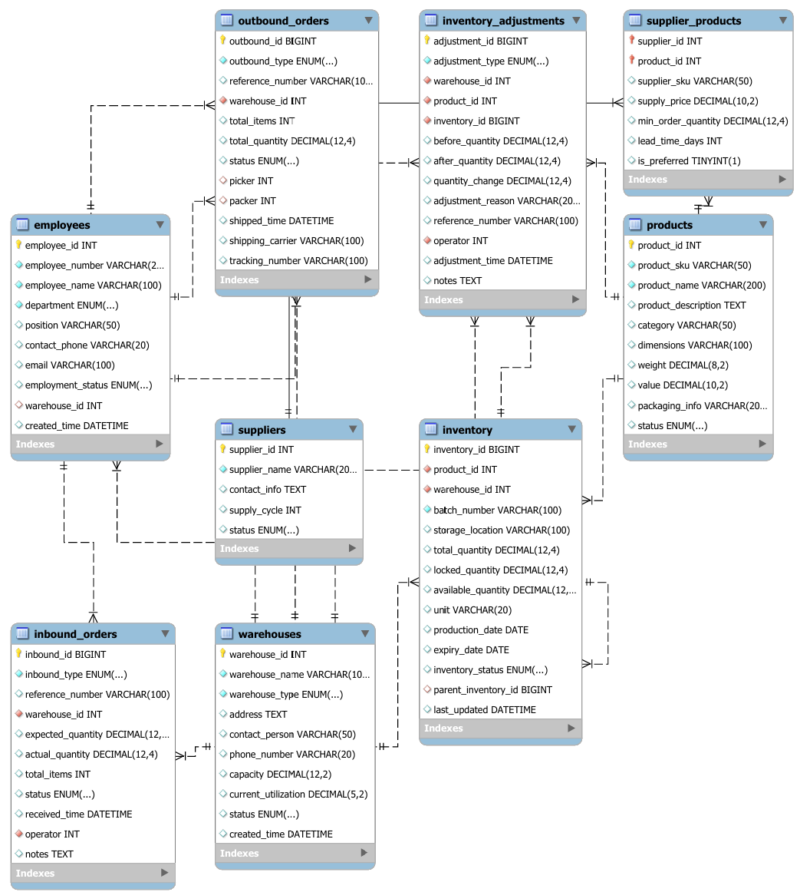

Main Discussion: Exclusion of Product Divisibility Consideration
In the design of this SQL database system, we have deliberately excluded the consideration of product divisibility (the ability to split products into smaller units for sales). This design decision is based on a clear division of responsibilities within the supply chain ecosystem and is justified by the following key reasons:
1. Operational Scope Alignment
Large-scale warehouses, which this system is designed to support, primarily function as bulk storage and distribution centers. Their core responsibility involves handling full-unit quantities for efficient regional distribution. The practice of splitting products into smaller sales units typically occurs at downstream endpoints in the supply chain, such as retail stores, small warehouses, or direct sales outlets that serve end consumers.

2. Process Efficiency Optimization
Maintaining product integrity in original packaging units allows for:
- Streamlined inventory management processes
- Optimized picking and packing operations
- Reduced handling costs and minimized potential damage
- Simplified stock counting and reconciliation procedures

3. System Performance Considerations
Excluding divisibility logic contributes to:
- Simplified database schema and reduced complexity
- Improved query performance for core warehouse operations
- Reduced computational overhead in inventory calculations
- More straightforward implementation of batch tracking and expiration management

4. Business Process Segregation
The supply chain is naturally segmented into distinct operational domains:
- Large Warehouses: Focus on bulk storage, cross-docking, and full-case distribution
- Distribution Centers: Handle case-breaking and mixed pallet building
- Retail Stores/Small Outlets: Manage individual unit sales and product splitting
This system intentionally focuses on supporting the first segment, ensuring optimal performance for high-volume, full-unit operations that characterize large warehouse environments.

5. Implementation Practicality
By maintaining a consistent unit-based approach, the system achieves:
- Clearer inventory accountability
- Simplified interface design with enterprise resource planning systems
- Reduced training requirements for warehouse staff
- More straightforward integration with automated storage and retrieval systems
This design philosophy ensures that the database system remains robust, scalable, and specifically tailored to the operational requirements of large warehouse facilities, while allowing specialized systems at the retail level to handle product splitting functionalities appropriate to their scale and business needs.

DDL.sql:

SET FOREIGN_KEY_CHECKS=0;

CREATE DATABASE warehouse_management;
USE warehouse_management;

CREATE TABLE warehouses (
warehouse_id INT PRIMARY KEY,
warehouse_name VARCHAR(100) NOT NULL,
warehouse_type ENUM('CENTRAL', 'REGIONAL', 'FRONT') NOT NULL,
address TEXT,
contact_person VARCHAR(50),
phone_number VARCHAR(20),
capacity DECIMAL(12,2),
current_utilization DECIMAL(5,2),
status ENUM('ACTIVE', 'INACTIVE') DEFAULT 'ACTIVE',
created_time DATETIME DEFAULT CURRENT_TIMESTAMP
) ENGINE=InnoDB;

CREATE TABLE suppliers (
supplier_id INT PRIMARY KEY,
supplier_name VARCHAR(200) NOT NULL,
contact_info TEXT,
supply_cycle INT,
status ENUM('ACTIVE', 'INACTIVE') DEFAULT 'ACTIVE'
) ENGINE=InnoDB;

CREATE TABLE products (
product_id INT PRIMARY KEY,
product_sku VARCHAR(50) UNIQUE NOT NULL,
product_name VARCHAR(200) NOT NULL,
product_description TEXT,
category VARCHAR(50),
dimensions VARCHAR(100),
weight DECIMAL(8,2),
value DECIMAL(10,2),
packaging_info VARCHAR(200),
status ENUM('ACTIVE', 'DISCONTINUED') DEFAULT 'ACTIVE'
) ENGINE=InnoDB;

CREATE TABLE supplier_products (
supplier_id INT,
product_id INT,
supplier_sku VARCHAR(50),
supply_price DECIMAL(10,2),
min_order_quantity DECIMAL(12,4),
lead_time_days INT,
is_preferred BOOLEAN DEFAULT FALSE,
PRIMARY KEY (supplier_id, product_id),
FOREIGN KEY (supplier_id) REFERENCES suppliers(supplier_id) ON DELETE CASCADE,
FOREIGN KEY (product_id) REFERENCES products(product_id) ON DELETE CASCADE
) ENGINE=InnoDB;

CREATE TABLE employees (
employee_id INT PRIMARY KEY,
employee_number VARCHAR(20) UNIQUE NOT NULL,
employee_name VARCHAR(100) NOT NULL,
department ENUM('WAREHOUSE_OPS', 'ORDER_PROCESSING', 'QUALITY_CONTROL', 'SYSTEM_ADMIN') NOT NULL,
position VARCHAR(50),
contact_phone VARCHAR(20),
email VARCHAR(100),
employment_status ENUM('ACTIVE', 'TERMINATED', 'LEAVE') DEFAULT 'ACTIVE',
warehouse_id INT,
created_time DATETIME DEFAULT CURRENT_TIMESTAMP,
FOREIGN KEY (warehouse_id) REFERENCES warehouses(warehouse_id) ON DELETE SET NULL
) ENGINE=InnoDB;

CREATE TABLE inventory (
inventory_id BIGINT PRIMARY KEY,
product_id INT NOT NULL,
warehouse_id INT NOT NULL,
batch_number VARCHAR(100) NOT NULL,
storage_location VARCHAR(100),
total_quantity DECIMAL(12,4) DEFAULT 0,
locked_quantity DECIMAL(12,4) DEFAULT 0,
available_quantity DECIMAL(12,4) DEFAULT 0,
unit VARCHAR(20) DEFAULT 'PCS',
production_date DATE,
expiry_date DATE,
inventory_status ENUM('NORMAL', 'HOLD', 'QUARANTINE') DEFAULT 'NORMAL',
parent_inventory_id BIGINT,
last_updated DATETIME DEFAULT CURRENT_TIMESTAMP,
FOREIGN KEY (product_id) REFERENCES products(product_id) ON DELETE CASCADE,
FOREIGN KEY (warehouse_id) REFERENCES warehouses(warehouse_id) ON DELETE CASCADE,
FOREIGN KEY (parent_inventory_id) REFERENCES inventory(inventory_id) ON DELETE SET NULL,
INDEX idx_warehouse_product (warehouse_id, product_id),
INDEX idx_batch (batch_number),
INDEX idx_expiry (expiry_date)
) ENGINE=InnoDB;

CREATE TABLE inbound_orders (
inbound_id BIGINT PRIMARY KEY,
inbound_type ENUM('PURCHASE', 'TRANSFER', 'RETURN') NOT NULL,
reference_number VARCHAR(100),
warehouse_id INT NOT NULL,
expected_quantity DECIMAL(12,4),
actual_quantity DECIMAL(12,4),
total_items INT,
status ENUM('PENDING', 'RECEIVING', 'COMPLETED', 'CANCELLED') DEFAULT 'PENDING',
received_time DATETIME,
operator INT NOT NULL,
notes TEXT,
FOREIGN KEY (warehouse_id) REFERENCES warehouses(warehouse_id) ON DELETE CASCADE,
FOREIGN KEY (operator) REFERENCES employees(employee_id) ON DELETE RESTRICT,
INDEX idx_warehouse_status (warehouse_id, status),
INDEX idx_reference (reference_number),
INDEX idx_received_time (received_time)
) ENGINE=InnoDB;

CREATE TABLE outbound_orders (
outbound_id BIGINT PRIMARY KEY,
outbound_type ENUM('SALES', 'TRANSFER', 'RETURN') NOT NULL,
reference_number VARCHAR(100),
warehouse_id INT NOT NULL,
total_items INT,
total_quantity DECIMAL(12,4),
status ENUM('PENDING', 'PICKING', 'PACKING', 'SHIPPED', 'CANCELLED') DEFAULT 'PENDING',
picker INT,
packer INT,
shipped_time DATETIME,
shipping_carrier VARCHAR(100),
tracking_number VARCHAR(100),
FOREIGN KEY (warehouse_id) REFERENCES warehouses(warehouse_id) ON DELETE CASCADE,
FOREIGN KEY (picker) REFERENCES employees(employee_id) ON DELETE SET NULL,
FOREIGN KEY (packer) REFERENCES employees(employee_id) ON DELETE SET NULL,
INDEX idx_warehouse_status (warehouse_id, status),
INDEX idx_shipment (shipping_carrier, tracking_number),
INDEX idx_shipped_time (shipped_time)
) ENGINE=InnoDB;

CREATE TABLE inventory_adjustments (
adjustment_id BIGINT PRIMARY KEY,
adjustment_type ENUM('COUNT', 'TRANSFER', 'WRITE_OFF', 'SPLIT') NOT NULL,
warehouse_id INT NOT NULL,
product_id INT NOT NULL,
inventory_id BIGINT NOT NULL,
before_quantity DECIMAL(12,4),
after_quantity DECIMAL(12,4),
quantity_change DECIMAL(12,4),
adjustment_reason VARCHAR(200),
reference_number VARCHAR(100),
operator INT NOT NULL,
adjustment_time DATETIME DEFAULT CURRENT_TIMESTAMP,
notes TEXT,
FOREIGN KEY (warehouse_id) REFERENCES warehouses(warehouse_id) ON DELETE CASCADE,
FOREIGN KEY (product_id) REFERENCES products(product_id) ON DELETE CASCADE,
FOREIGN KEY (inventory_id) REFERENCES inventory(inventory_id) ON DELETE CASCADE,
FOREIGN KEY (operator) REFERENCES employees(employee_id) ON DELETE RESTRICT,
INDEX idx_warehouse_product (warehouse_id, product_id),
INDEX idx_adjustment_time (adjustment_time),
INDEX idx_reason (adjustment_reason)
) ENGINE=InnoDB;

SET FOREIGN_KEY_CHECKS=1;

